Request for Quotation

FROM | NORWEGIAN REFUGEE COUNCIL
Address | NRC- Sudan
City | Port Sudan - CO
Country | Sudan
Phone # | 249110030099
Email | SD.procurement@nrc.no nuseraldeen.eisa@nrc.no  mohammed.salim@nrc.no

TO

Address

City

Country

Phone #

Email

The office of the Norwegian Refugee Council invites your company to submit a price quotation for the following items in accordance with the requirements detailed below. You may use your company format, or fill up the table below. Please read carefully the instructions on page 2.

Request for Quotation Requirements (To be filled by NRC Procurement staff)
RFQ # : | PF-PS-1105 | Currency | USD
RFQ Issuing Date: | 06/11/2025 | Bid Validity Period (days): | (Preferably 30 days)
RFQ Closing Date: | 20/11/2025 | Required Delivery Date:
RFQ Closing Time: | 03:00 PM (GMT +2) | Required Delivery Destination: | NRC – Port Sudan Office, Hay El Matar.
Questions to the RFQ | SD.procurement@nrc.no | Required Delivery Terms:

To be filled by NRC |  |  |  | To be filled by Supplier
Item  # | Description/ Specifications | Unit | Quantity Required | Unit Price | Total Price
1 | Treadmill Machine - 150 Kg  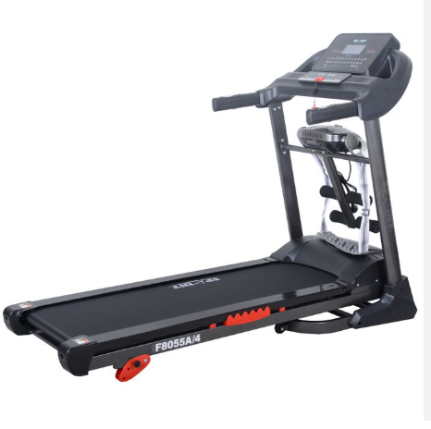 | PC | 2
2 | Dumbbell set ( 2.5- 50 ) Kg  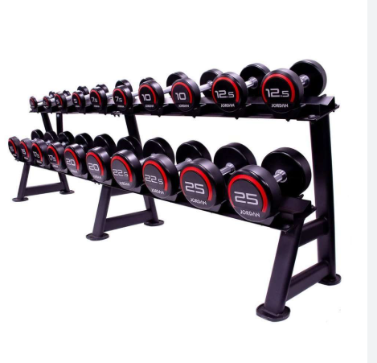 | SET | 1
3 | Indoor Exercise Bicycle  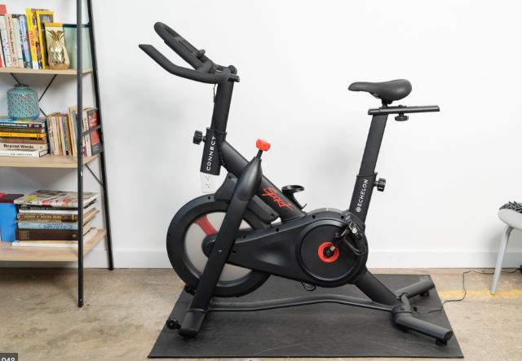 | PC | 2
4 | Exercise Bench   | PC | 3
5 | Adjustable Skipping rope  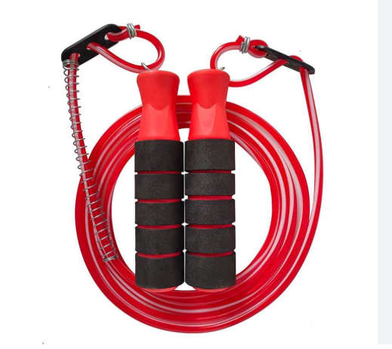 | PC | 2
6 | Push up handle (set)  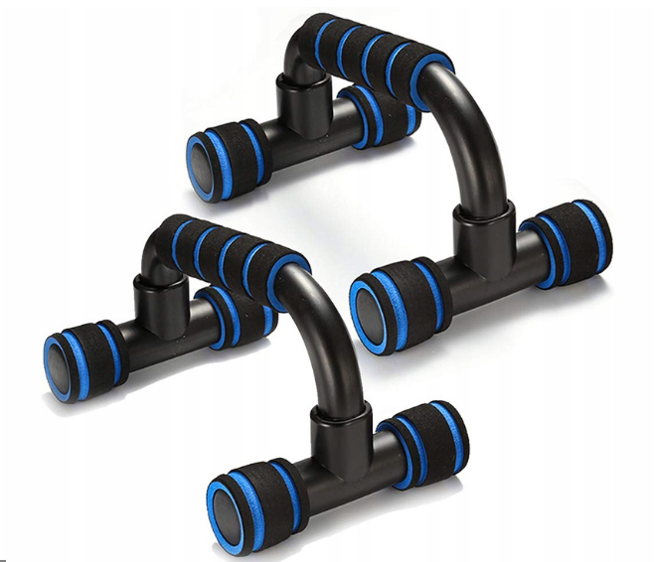 | SET | 2
7 | Gym Rubber Floor matt  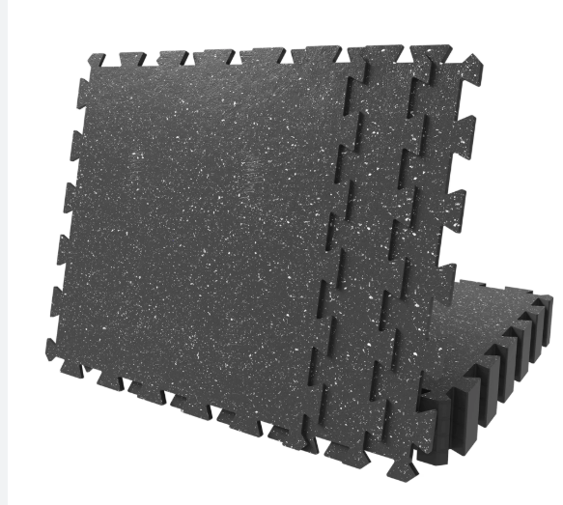 | PC | 10
8 | Multi-Adjustable Bench,  - (Three Bars)  - Pair of 5 kg Olympic weight frames - triple grip  - Pair of 10kg Olympic weight frames - triple grip  - Pair of 15kg Olympic weight frames - triple grip | PC | 3
9 | HOME GYM (G4)  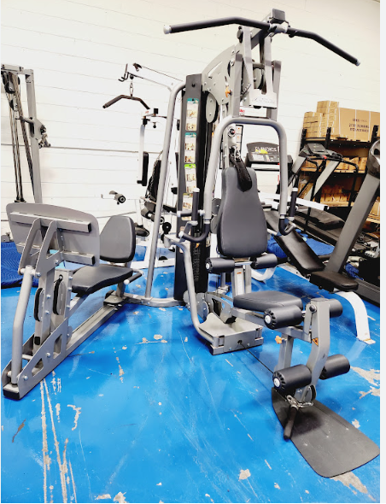 | PCs | 1
10 | Table tennis table( standard size ) | PC | 1
11 | Large Yoga mat   | PC | 10
12 | Gym ball 65/75 Cm   | Person | 3
GRAND TOTAL (Including Transport and VAT)

Delivery Lead Time (in days, from receipt of NRC Purchase Order)

Bid Validity Period (in days from receipt of NRC Purchase Order):

Defects liability and guarantee period:

Country of origin of the goods

Name

Position

Date Signature

Stamp

RFQ Terms & Conditions

- Manner of Submission:
- By hand in a sealed envelope to NRC office located Address
- By email to the dedicated and secured email address: email @nrc.no (offers received on other email addresses will not be considered)
- Before the Closing date & Time mentioned above. Companies who do not submit their quotation by this deadline will not be considered

- Requirements:
- All Bids must include all customs and taxes payable in the country of delivery unless the RFQ specifically requests differently
- Bids must be submitted in the currency indicated in the RFQ. Bids in other currency might not be accepted
- Bids must be valid for the validity period indicated in the RFQ. Bids not meeting this validity period might be disqualified
- All enquires and questions should be addressed to the email given in the RFQ details section. All questions and answers will be shared with all invited suppliers.
- NRC reserves the right to accept or reject the whole or part of your quotation based on the information provided. Incomplete quotations which do not comply with our conditions will not be considered.
- Provide Samples for the items listed in annex, together with your offer (if relevant)

Assessment Criteria:
- All bids received and accepted will be evaluated based on the following:
- Step 1: Administrative compliance check: Each bid will be checked to ensure compliance with all the RFQ requirements
- Step 2: Technical Evaluation: All bids will be technically evaluated based on “best value for money”
- Step 3: Financial Evaluation: Price in comparison to NRC established expectation and in comparison, to other bidders of comparable technical quality
- Price (including transport)
- Quality
- Delivery Time

Payment terms:
- Payment will be made within 30 days of receipt of goods, by bank transfer/cheque only.

Mandatory documents:

Requested document | Check (Y/N)
Company registration Certificate, or commercial lenience شهادة تسجيل /رخصة تجارية
Vat Registration Certificate التسجيل في القيمة المضافة
Tax registration certificate الرقم التعريفي الضريبي
Passport Copy / ID of company director صورة من أثبات الشخصة \ جواز بطاقة قومية
NRC RFQ to be signed and stamped in each page التوقيع والختم في كل الصفحات

Assessment Criteria:

- All bids received and accepted will be evaluated based on the following:
- Step 1: Administrative compliance check: Each bid will be checked to ensure compliance with all the RFQ requirements

Step 1: Administrative Compliance Check
The Administrative Compliance Check will be conducted to ensure that all bidders meet the necessary legal and administrative requirements. Bids that do not meet these requirements will be disqualified from further evaluation. The criteria for this step are outlined below

Category | Criteria | Details | Score (Pass/Fail)
Administrative | Tax Registration (Compulsory) | A copy of the tax registration document is required to verify tax compliance
Administrative | Reference and Proof of Experience (Optional) | Documentation proving relevant experience in handling similar contracts, including references
Administrative | Copy of Company Registration (Compulsory) | A copy of the company registration document is required to confirm the legal status of the business

- Step 2: Technical Evaluation

A Technical Evaluation of all RFQs received will be conducted for bidders that pass Step 1 Administrative compliance check. The criteria that will be used to evaluate and score the RFQs are outlined below:

Category | Criteria | Details | Score (0-10)
Technical Specifications | Equipment Type & Functionality | Does The Equipment meet the required type and functions (cardio, strength, free weights, etc.)?
Technical Specifications | Quality & Standards | Quality certifications,  duration of warranty and coverage for defects  Availability of spare parts and technical support
Technical Specifications | Delivery Timeframe | ability to deliver within the required timeframe,
Total Score:

- Scoring Key

- 0 = Not at all compliant
- 5 = Somewhat compliant
- 10 = Fully compliant

- : Step 3: Financial Evaluation

Following the Technical Evaluation, a Financial Evaluation will be conducted for bidders that meet the technical requirements. The criteria that will be used to evaluate and score the bids are outlined below:
Category | Criteria | Details
Financial | Unit & Total Price Transparency | Prices are clearly listed per item and summarized overall
Financial | Tax & Delivery Inclusion | Indicates whether prices include applicable taxes and delivery costs
Financial | Payment Terms | Includes payment schedule, conditions, flexibility. (30 Days)
Financial | Price Competitiveness | Offer is competitive with market rates or better than other submissions

- Next Steps
- Conduct Administrative Compliance Check: Evaluate each bid against the criteria in Step 1
- Disqualify Non-Compliant Bids: Remove any bids that do not meet the administrative requirements.
- Conduct Technical Evaluation: For bids that pass the administrative compliance check, evaluate based on the Technical Evaluation criteria in Step 2.
- Score Each Bid: Assign scores based on the 1–5 scale for each criterion in the Technical Evaluation.
- Conduct Financial Evaluation: For bids that pass the Technical Evaluation, evaluate based on the Financial Evaluation criteria in Step 3.
- Score Each Bid: Assign scores based on the 1–5 scale for each criterion in the Financial Evaluation.
- Compile Results: Summarize the scores from all evaluations to determine the overall ranking of each bid.

Selection Criteria :

# | Criteria | Max Score | Scoring Guidelines
1 | Technical Specifications Compliance | 20
2 | Unit Price | 30
3 | Delivery Timeframe | 20
4 | Provide warranty | 20
5 | Past Experience | 10

NRC is obliged to ensure that its procurement decisions are clearly justified and documented and keeping within the Donors mandatory principles. In that regard, full and on-the-spot access must be granted to representatives of NRC, the Donor or any organisation or person mandated by it, to premises belonging to NRC or its contractors. The right to access shall include all documents and information necessary to assess, or audit the implementation of the contract.  NRC also expects suppliers who process personal data to comply with the General Data Protection Regulation (EU GDPR) and any relevant national legislation. Suppliers processing personal data on an NRC contract will be required to sign a data processing / sharing agreement as part of the contract. Refusal to sign such an agreement constitutes refusal of the contract terms and forfeiture of the contract on the part of the supplier.  If the activities of the contract take place in areas with Explosive Hazards, NRC accepts no liability for injury and/or death to contractor’s staff or damage to contractor’s property. | Anti-money laundering, anti-bribery, anti-corruption and anti-terrorism legislation and donor regulations require NRC to screen contractors against various international lists to ensure due diligence. Submission of the quotation constitutes acceptance of these screening practices.  NRC aims to purchase products and services with minimum environmental impact. Environmental considerations form part of the NRC selection criteria, and NRC reserves the right to reject quotations provided by suppliers not meeting these standards.  All suppliers doing business with NRC should maintain high standards on ethical and environmental issues, respect and apply basic human and social rights, ensure non-exploitation of child labour, and give fair working conditions to their staff. Suppliers will be required to sign and submit an Ethical Standards Declaration, together with their bid.  NRC reserves the right to reject quotations provided by suppliers not meeting these standards.

Signature & Stamp

